Trace2Learn Phase III

# Summary of Enhancements

Add the following features to Collections:

1.  **Categories**:  I'd like to be able to assign 1 or more category (e.g. Grammar, Phonetic, etc.) for each Collection - these categories are relevant to Chinese characters.  The categories will have small color icons, which would be displayed next to each Collection on the initial browse screen.

2.  **Narration**:  A few paragraphs of explanation, entered via the admin app, which the user could pull up anytime from an "info" icon to give context to the Collection.

3.  Differentiation between admin and user-defined Collections.  Collections created in the admin app will always be “admin”. Collections created in the end-user app will automatically be user-defined, and users may only edit/delete/add words to user-defined Collections.

# Collection Categories

There are 4 fixed Categories for Collections, as shown below. A Collection may have zero , 1 or more Categories. The user will assign them through the “Assign Categories” context menu on Browse All Collections. The end-user app may only do this for user-defined Collections.

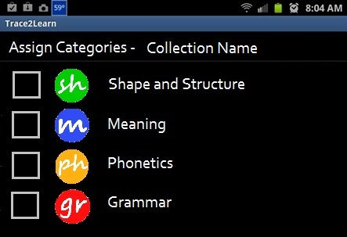

Once defined, the Categories and icons will be displayed in these locations:

1. below each item in the Browse All Collections view, as shown below;
2. below the Collection name when viewing the words within the Collection.

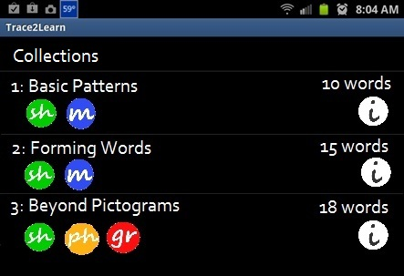

# Collection Narration

This is a brief description of the Collection, entered via a context menu “Edit Narration” on Browse All Collections. The end-user app may only do this for user-defined Collections.

The narration will be available via the “info” icon – the text should be displayed on a scrollable pop-up screen that the user can dismiss by clicking (x). The narration screen should also display the Category icons and names, if any are assigned to the Collection.

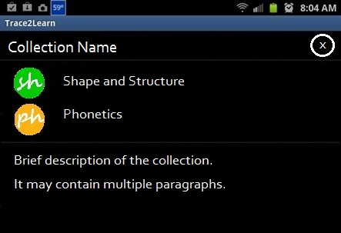

# Category Icons

|  |  |
| --- | --- |
| Info | C:\Users\Joe\Desktop\Life\Joe\Chinese\icons\icon-info.png |
| ‘Shape and Structure’ Category | C:\Users\Joe\Desktop\Life\Joe\Chinese\icons\icon-shape.png |
| ‘Meaning’ Category | C:\Users\Joe\Desktop\Life\Joe\Chinese\icons\icon-meaning.png |
| ‘Phonetic’ Category | C:\Users\Joe\Desktop\Life\Joe\Chinese\icons\icon-phonetics.png |
| ‘Grammar’ Category | C:\Users\Joe\Desktop\Life\Joe\Chinese\icons\icon-grammar.png |

# Bug Fixes

1. In Browse All Characters, Filter doesn’t match tags if there are no key-value attributes defined.
2. When browsing a Collection, **Playback** mode should auto-progress to next word, same as **Practice** mode
3. When browsing a Collection, please remove the pop-up “Collection: 1 of N” – this information is already shown at top of the screen